**Advance Organizer:**

**An instructional technique that helps people understand new information in terms of what they already know.**

Our minds are constantly looking to make associations and connections between what lays behind us and what lays before us. Often an automatic process, the human brain seeks to find correlations that help us to filter and process an almost endless stream of sensory data. As designers and educators, we can double down on this system to facilitate learning and retention of new information by using the design principle of advance organizers. First championed in the early 1960s as part of Ausubel’s Subsumption Theory, advance organizers are an instructional technique that helps people understand new information in terms of what they already know. This allows for the introduction of new material within a structured framework that prepares the learner to synthisize new with existing knowledge. From a design perspective, Advance Organizers tend to fall into one of two categories: expository and comparative. Expository Advance Organizers are useful when presenting information that is unfamiliar or novel to the group, such as when introducing the concept of government to a middle school social studies class for the first time. On the other hand, Comparative Advance Organizers are valuable when covering material that the audience has some level of previous knowledge with. For example, when moving from the concept of monarchical government to democratic forms of government within that same middle school social studies class. Four established types of Advance Organizers are Narrative, Skimming, Graphics, and Text.

Advance organizers capitalize on natural learning processes to reduce performance load and increase lesson effectiveness. They help retention by layering new information with old and using recall to reinforce and tie concepts together. Advance organizers are best used for linear sequential instruction, and may also act as a Rosetta stone of sorts by helping to make sense of new material. Advance organizers integrate with several [UDL](http://udlguidelines.cast.org/) principles by Recruiting Interest, increasing Comprehension, and Facilitate managing information & resources. Finally, they may be paired with other design principles such as recognition over recall and framing to act as a natural bridge when transitioning to a new topic. Key to the success of any advance organizer is that it effectively frames new information in relation to concepts the student already understands. There is a high likelihood that you have experienced an advance organizer in previous lessons and may have used one yourself. Below are five functional examples of advance organizers.

**Narrative advance organizer**

The Narrative advance organizer can be a comfortable place to start because it relies on the principle of storytelling to prepare the audience for instruction. This can be a terrific utility strategy that works across a broad range of settings and topics without the use of additional materials. For example , prior to a nature field trip the teacher might relay a cautionary tale about plant or mushroom toxicity so that students or aware when they hit the trail. That same story could be useful in a Health or Chemistry class when introducing plant use concepts. Key to the narrative Advance Organizer is ensuring that the story speaks directly to the topic and the audience, as opposed to simply telling a story.

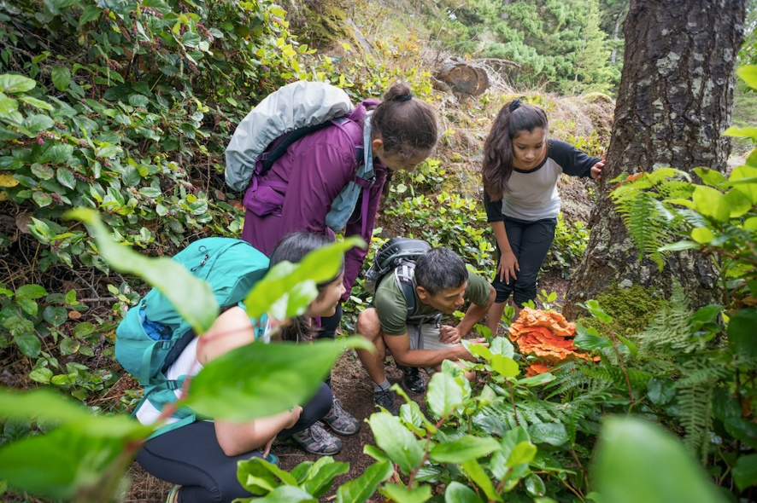

**Skimming**

Another relatively simple advance organizer that requires little additional material is skimming. Skimming is a pre-reading technique that Can be used by itself or with textbook use strategies, such as [SQ3R](https://www.thoughtco.com/sq3r-reading-comprehension-strategy-1857535) (survey, question, read, recite, review), and requires the student to skim upcoming sections of their textbooks, particularly the headings and subheading, in order to familiarize and orient to the information that will be introduced. These two examples also employ graphics and iconography to make the concept more approachable and memorable .

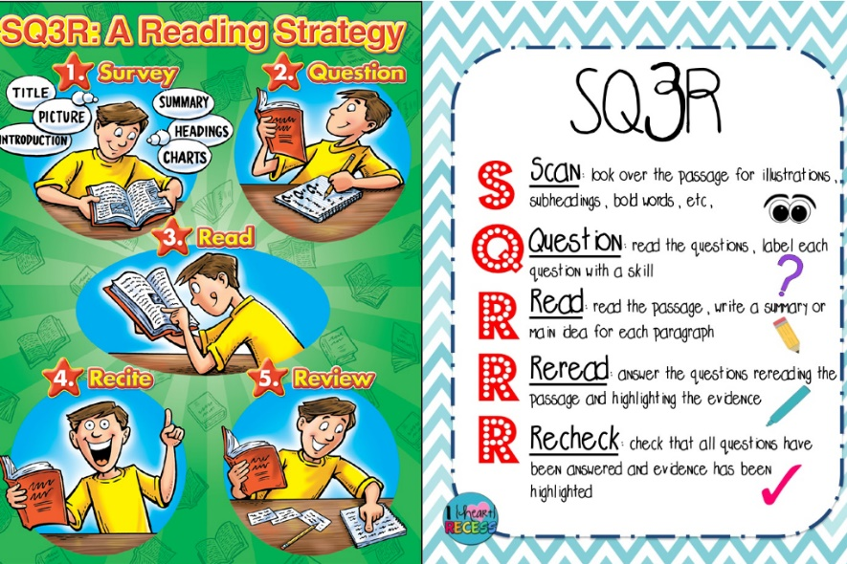

**Text advance organizer**

The Text advance organizer can be particularly helpful with note-taking and written organization. A prime example of a text advance organizer would be a written or printed outline, which the student then fills in throughout the lesson. The [KWL chart](https://knilt.arcc.albany.edu/UNIT_4-_Examples_of_Advance_Organizers) , for instance, asks the student what they Know and Want to know concerning a given topic, and then what they Learned about the topic, once the lesson reaches its conclusion.

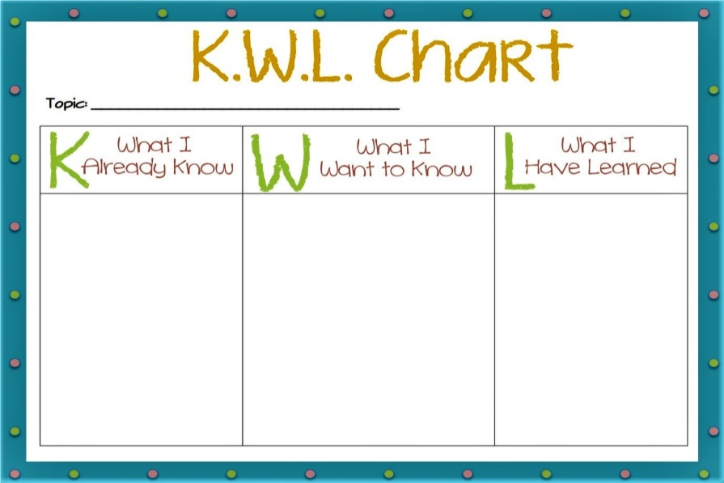

**Graphic advance organizer**

Graphic advance organizers are a useful way to organize, visualize, and connect information. The concept map accomplishes this by visually illustrating how information fits and compares. These are especially useful for organizing and picturing how ideas connect with one another. A biology lesson could be one natural place to use a concept map to better understand cell components as students move between sub-topics.

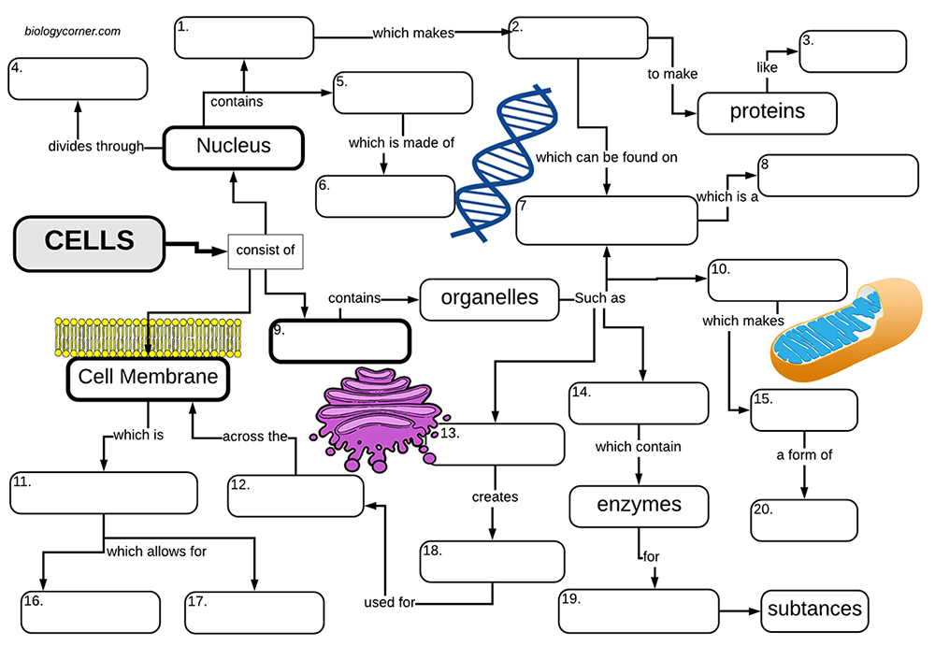

**Graphic advance organizer**

Venn diagrams are another example of the graphic advance organizer which are used to illustrate overlapping ideas or commonalities. These diagrams are a great use case because they fit existing mental models and are easy for most people to grasp. Here is a sample of a Venn diagram that shows commonalities between plant and animal cells. Notice the added imagery helps to visualize the concepts but may be better served in a different layout using better symmetry and alignment.

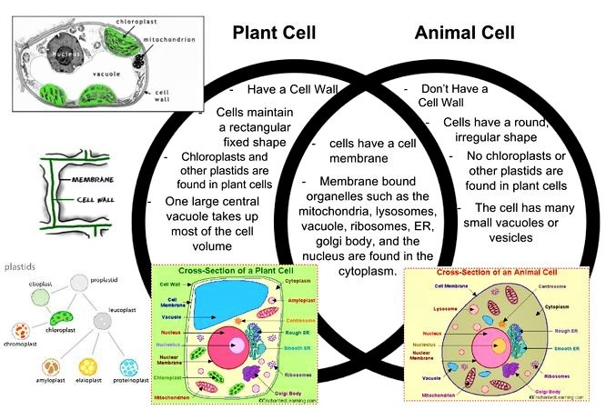

Duane Gregory - WTAMU course 6310 - Summer II - 2020